Lab 05

Ques 1: Write the LEX and YACC source to recognize the following:

a) General Template:

The template for the C program is

#include<stdio.h>

int main( )

{

}

PGM 🡪 HEADER INT MAIN LB RB LCB RCB

|  |  |
| --- | --- |
|  |  |
|  |  |

b) Declaration statements:

Allow declaration statements inside the program body. Integer variables separated by

comma can be declared inside the program body. A program can have multiple

declaration statements. Variables are sequence of lower-case alphabets. Each

declaration statement is ended by a semicolon.

int a, b;

PGM 🡪 HEADER INT MAIN LB RB LCB BODY RCB

BODY 🡪 DECL_STMTS

DECL_STMTS 🡪 DECL_STMT DECL_STMTS | DECL_STMT

DECL_STMT 🡪 INT VAR_LIST SC

VAR_LIST 🡪 VAR COMA VAR_LIST | VAR

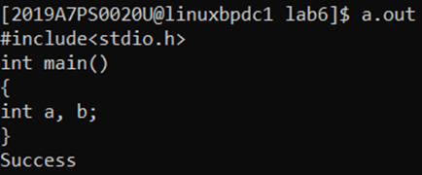

c) OPERATORS &amp; PROGRAM STATEMENTS:

Allow declaration statements to be followed by program statements inside the

program body. Program statements are ended by a semicolon. Program statements

can be arithmetic expressions involving +-*/ operators.

PGM 🡪 HEADER INT MAIN LB RB LCB BODY RCB

BODY 🡪 DECL_STMTS PROG_STMTS

DECL_STMTS 🡪 DECL_STMT DECL_STMTS | DECL_STMT

PROG_STMTS 🡪 PROG_STMT PROG_STMTS | PROG_STMT

DECL_STMT 🡪 INT VAR_LIST SC

VAR_LIST 🡪 VAR COMA VAR_LIST | VAR

PROG_STMT 🡪 VAR EQ A_EXPN SC

A_EXPN 🡪 A_EXPN OP A_EXPN | LB A_EXPN RB | VAR